Chapter 5, Solution 17.

- G = 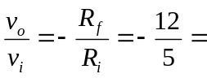 –2.4
- 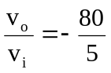 = –16
- 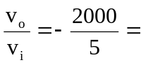 –400

(a) –2.4, (b) –16, (c) –400

